Final Project Proposal

Group Members: Chenhan Luo, Nianze Guo, Ze Yang, Jiaxin Liu

Project Title: Fitness Tracker

Summary:
We propose to develop a personalized fitness tracker app that provides users with tailored exercise recommendations based on their height, weight, and personal preferences. The app aims to simplify the process of selecting suitable exercises by considering individual physical attributes and fitness goals. Users will input their personal data and preferences, and the app will generate customized exercise plans to help them achieve their health and fitness objectives.
Our goal is to create an intuitive and user-friendly application that not only recommends exercises but also educates users about the benefits of different activities. By offering personalized guidance, we hope to motivate users to engage in regular physical activity and lead healthier lifestyles.
Description:
We aim to develop a personalized fitness tracker app that provides users with customized exercise recommendations tailored to their unique physical attributes—such as height and weight—and personal preferences. The primary goal of our application is to simplify the often overwhelming process of selecting appropriate exercises by taking into account individual factors and fitness goals.

The app will enable users to input their personal data (such as height, weight, age, and fitness level) and specify their preferences (such as preferred types of exercises, target areas, or fitness objectives). Based on this information, the app will generate customized workout plans designed to help users achieve their health and fitness goals more effectively. In addition to personalized recommendations, the app will provide educational content to inform users about the benefits of different activities and exercises, enhancing their understanding of physical fitness and health.

By offering tailored guidance and an intuitive, user-friendly interface, our fitness tracker app aims to motivate users to engage in regular physical activity, ultimately leading to healthier lifestyles. The app will bridge the gap between individual fitness needs and exercise planning, making it easier for users to commit to regular workouts and make informed choices about their health.

Creative component:
The following creative components are in our consideration:
- Customized Workout Calendar: Users can set reminders about when to do the exercise, and users can schedule their workouts and track their adherence to their fitness plans. It can help users visualize their workout routine and stay organized with their fitness goals.

- Goal Achievement Badges: Users can get different digital badges when they have accomplished different milestones about their fitness plan, or they will get the badge if they complete challenges.

- More Detailed Fitness Plan Recommender: We ask users to give us a target calories they want to spend everyday. Based on a recommended system, we create a plan for the users.

Usefulness:
This app will be a good choice for both people who want to keep fit and be healthy. This app will recommend the top 5-10 exercise options to the users, which not only allows them to choose the most suitable exercise but only know more about each kind of exercise. Users can input their own weight, height, and other related information to filter out the suitable fitness recommendations. Users can search the type of exercise they want based on the calories of each exercise. There will be a video for each exercise which allows users to learn how to do the exercise correctly.

Realness:
Both in csv:
https://www.kaggle.com/datasets/aadhavvignesh/calories-burned-during-exercise-and-activities
Data size: 249 rows (cardinality) and 6 columns (degree)
The dataset captures several key pieces of information:
- Activity Name: Specifies the type of exercise or physical activity, such as cycling, running, swimming, etc.
- Calorie Expenditure Data: Provides the estimated number of calories burned for individuals with different body weights (130 lb, 155 lb, 180 lb, and 205 lb) while performing each activity for one hour.
- Calories per kg: A normalized measure of calorie expenditure per kilogram, allowing for easy comparison across different body weights.

https://www.kaggle.com/datasets/niharika41298/gym-exercise-data
Data size: 2919 rows (cardinality) and 9 columns (degree)
The dataset captures several key pieces of information:
- Title: Name of the exercise (e.g., "Partner plank band row," "Banded crunch isometric hold").
- Description (Desc): Detailed descriptions of how each exercise is performed, including specific instructions and form tips.
- Type: The category of exercise, such as "Strength," indicating the exercise type.
- BodyPart: The specific body part targeted by the exercise (e.g., "Abdominals").
- Equipment: Indicates the type of equipment needed for each exercise (e.g., "Bands").
- Level: The difficulty level of the exercise, ranging from beginner to advanced (e.g., "Intermediate").
- Rating and Rating Description (RatingDesc): User ratings for each exercise, potentially providing feedback or additional insights on the exercise's effectiveness or popularity.

UI mock-up:
Initial Interface
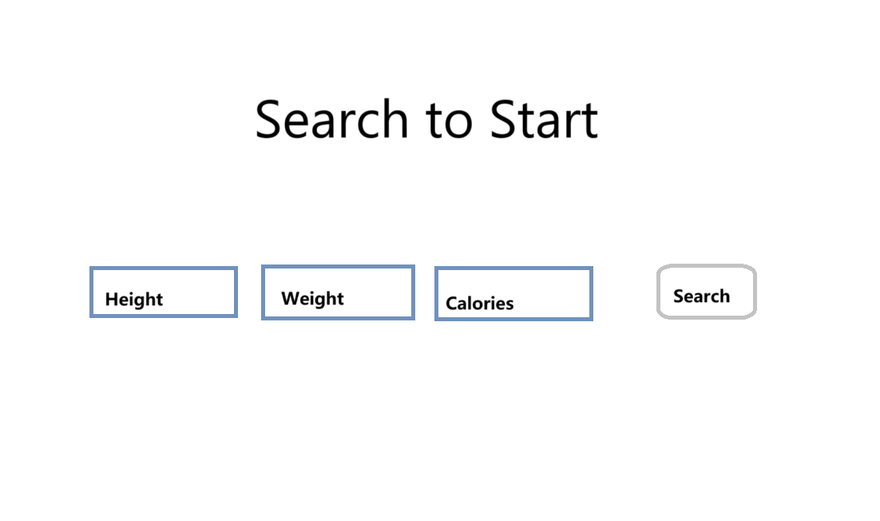
Results Display
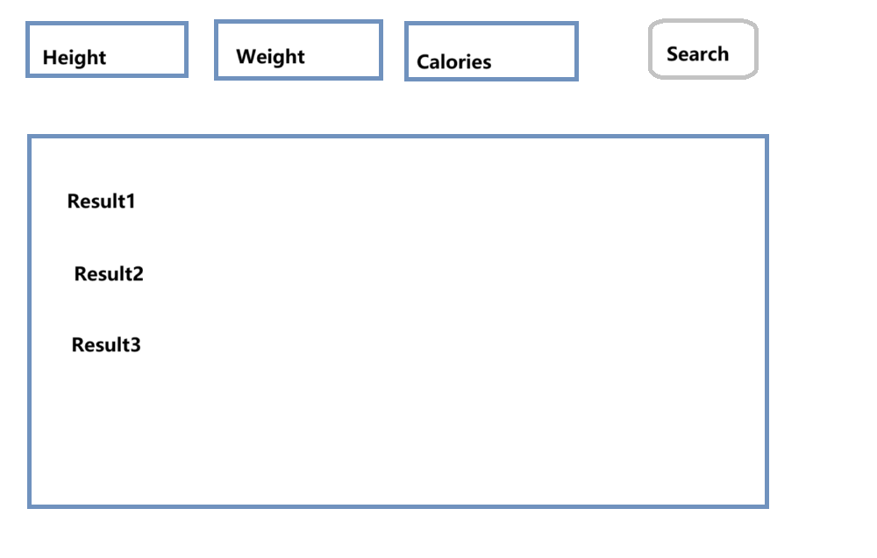
Distribution:

Front-End Development(Ze Yang):
- Designing the user interface and user experience (UI/UX).
- Developing the profile setup and exercise recommendation screens.

Back-End Development(Jiaxin Liu):
- Setting up server-side logic and database integration.
- Developing the API for data communication between front-end and back-end.

Data Management(Chenhan Luo):
- Sourcing and processing datasets (exercise database, caloric expenditure data).
- Designing and managing the database schema.

Quality Assurance and Documentation(Nianze Guo):
- Conducting testing (unit, integration, and user acceptance testing).
- Identifying and resolving bugs or performance issues.

